Lot 61 Reduced Levels and Sections at Side Boundaries

Using the given information do the following

- Book staff reading (rise & fall method) onto the rise & fall template
(Do the arithmetical check to confirm the correct booking in rise & fall column)
- Use the assumed reduced level (RL) at ‘A’ to calculate reduced level for each station in alphabetical order.
- Draw section views (ground profile) of the site boundaries using a horizontal scale of 1:200 and a vertical scale of 1:50 (Select a baseline for the vertical section of 6 metre)
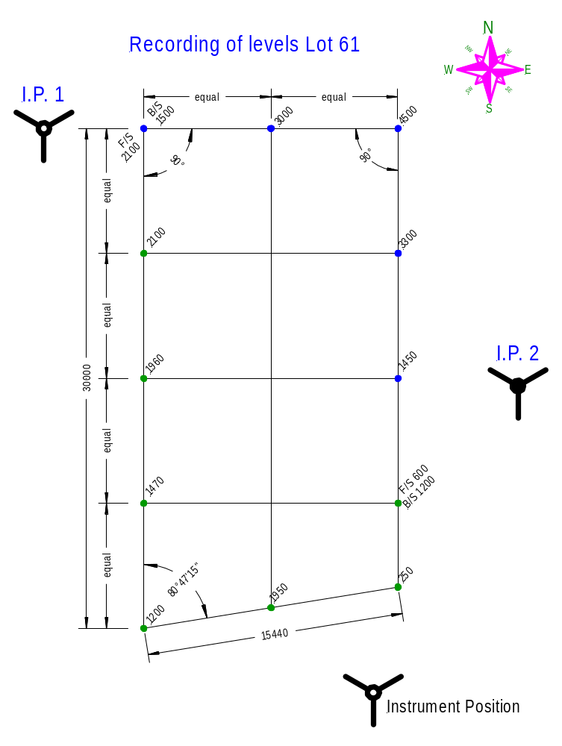
Rise & Fall Template

Station | Back- | Inter- | Fore- | Rise | Fall | Reduced | Distance | Remarks
Station | sight | mediate | sight | Rise | Fall | level | Distance | Remarks
A
B
C
D
E
F
G
H
J
K
L
M
N
P
Q
R
S
T
U
V
W
X
Y
Z

